Create Resource Group



What is a resource group

* A container
* Holds related resources for an Azure solution
* Can include all the resources for the solution
* Or only those resources that you want to manage as a group

Create resource groups

1. Sign in to the Azure portal.
2. Select Resource groups

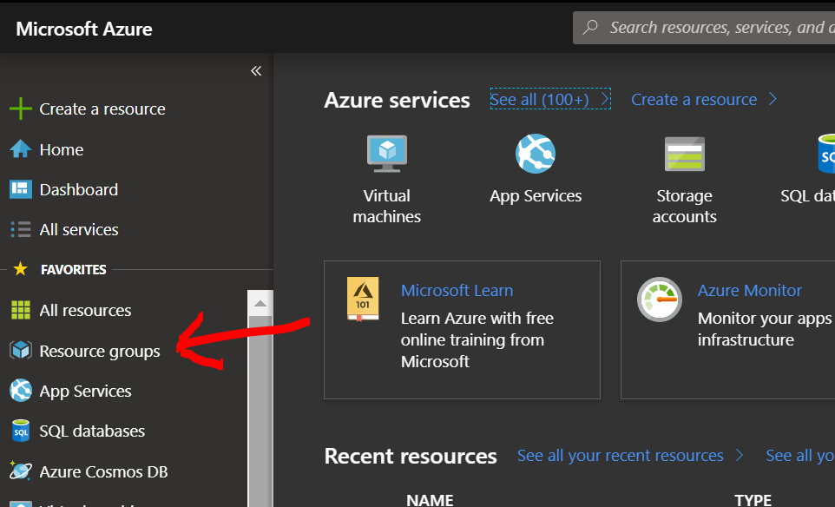

1. Add

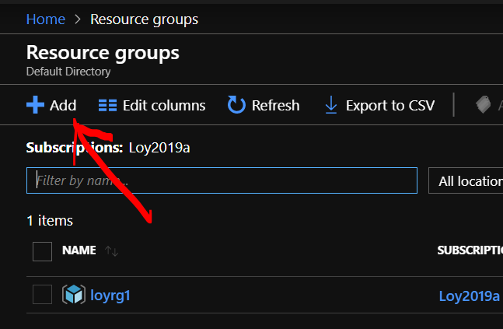

1. Enter the following values

* **Subscription:** Select your Azure subscription.
* **Resource group:** Enter a new resource group name.
* **Region:** Select an Azure location, (Asia Pacific) Southeast Asia

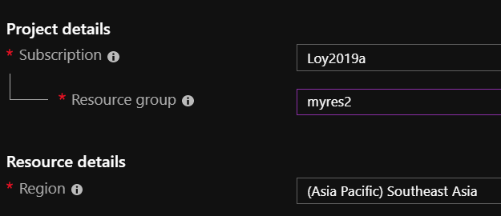

1. Select Review + Create
2. Select Create. It takes a few seconds to create a resource group.
3. Select Refresh

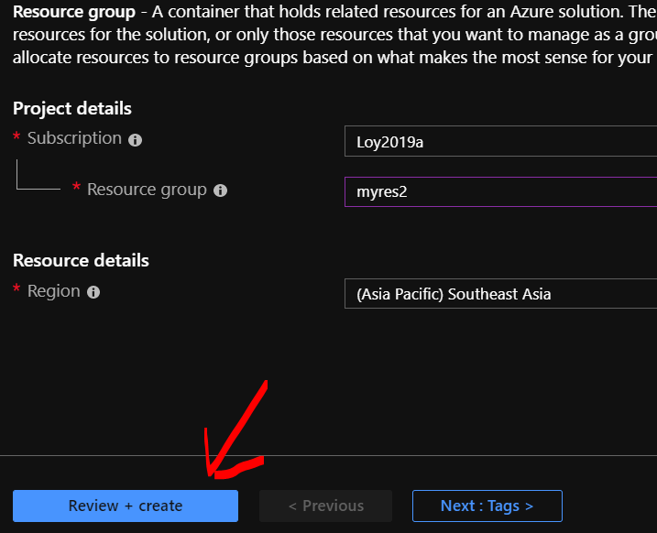

1. Pin the new resource group into the Dashboard

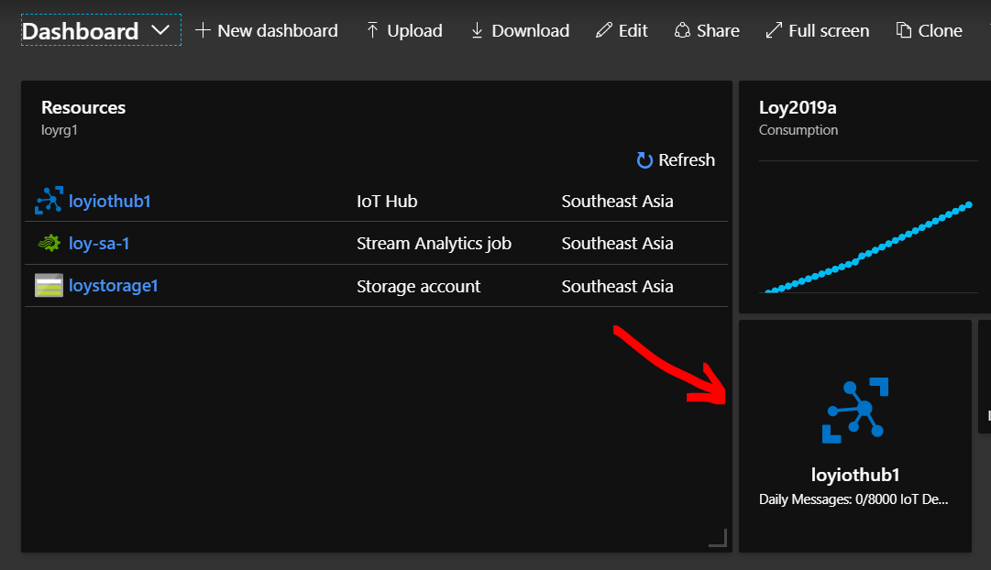

What's next?

